**HANDOVER MANAGEMENT IN GSM CELLULAR SYSTEM**

**BY**

**PIUS ENECNEOJO DORCAS**

**ST/CS/ND/19/241**

**BEING A SEMINAR PAPER**

**PRESENTED TO THE DEPARTMENT OF COMPUTER SCIENCE**

**SCHOOL OF SCIENCE AND TECHNOLOGY**

**FEDERAL POLYTECHNIC, MUBI ADAMAWA STATE**

**DECEMBER, 2021**

**ABSTRACT**

*Handover mechanism is extremely important in cellular network because of the cellular architecture employed to maximize spectrum utilization. Handover is the procedure that transfers an ongoing call from one cell to another as the user moves through the coverage area of cellular system. One way to improve the cellular network performance is to use efficient handover prioritization schemes when user is switching between the cells. In this thesis an analytical framework has been presented that can enhance considerably the handover call mechanism in wireless network. Some advance schemes namely, guard channels, call admission control and handover queuing are discussed. All these of prioritizations schemes have a common characteristic and that is, reducing the call dropping probability at the expense of increased call blocking probability. Efficient prioritization scheme accommodates a number of new calls while guarantees the quality of service (QoS) of handover call.*

**INTRODUCTION**

During the early 1980s, analog cellular telephone systems were experiencing rapid growth in Europe, particularly in Scandinavia and the United Kingdom, but also in France and Germany. Each country developed its own system, which was incomplete with everyone else’s in equipment and operation. This was an unwanted situation, because not only was the mobile equipment limited to operation within national boundaries, which in a unified Europe were ever more unimportant. But there was also a very limited market for each type of equipment, so economics of scale and the subsequent savings could not be realized (Katzela, 2006).

**GSM ARCHITECTURE**

The communication between two people – the caller and the called person – is the basic service of all telephone networks. To provide this service, the network must be able to set up and maintain a call, which involves a number of tasks: identifying the called person, determining the location, routing the call and ensuring that the connection sustained as long as the conversation lasts. After the transaction, the connection is terminated and (normally) the calling user is charged for the service he has used (Mandjes & Tutschku, 2006).

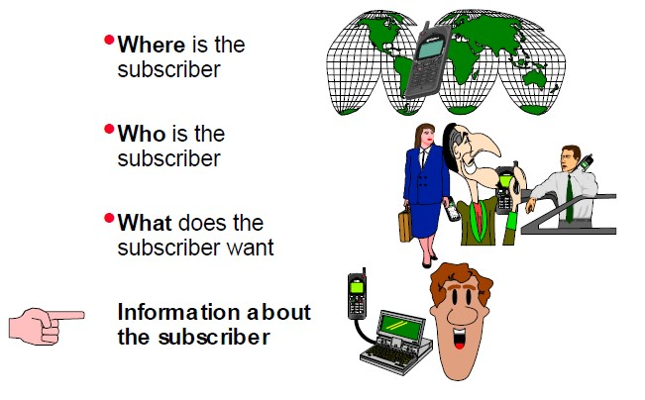

Figure 1: Information required by a mobile communications network.

The Europeans realized this early on and in 1982 the Conference of European Post and Telegraphs (CEPT) formed a study group called the Group Special Mobile (GSM) to study and develop a pan-European public land mobile system. The proposed system had to meet certain criteria:

1. Good subjective speech quality
2. Low terminal and service cost
3. Support for international roaming
4. Ability to support handheld terminals
5. Support for range of new services and facilities
6. Spectral efficiency
7. ISDN compatibility (Ghaderi, 2008).

Pen-European means European-wide. ISDN throughput at 64Kbs was never envisioned, indeed, the highest rate of a normal GSM network can achieve is 9.6Kbs. Europe saw cellular service introduced in 1981, when the Nordic Mobile Telephone System or NMT450 began operating in Denmark, Sweden, Finland and Norway in the 450 MHz range. It was the first multinational cellular system. In 1985 Great Britain was started using Total Access Communication System or TACS at 900 MHz range (Ghaderi, 2008).

The communication between two people – the caller and the called person – is the basic service of all telephone networks. To provide this service, the network must be able to set up and maintain a call, which involves a number of tasks: identifying the called person, determining the location, routing the call and ensuring that the connection sustained as long as the conversation lasts. After the transaction, the connection is terminated and (normally) the calling user is charged for the service he has used (Yliopisto, 2006).

In a GSM network, this decentralized intelligence is implemented by dividing the whole network into three separate subsystems (Nielsen & Wigard, 2000):

1. Network Switching Subsystem (NSS)
2. Base Station Subsystem (BSS)
3. Network Management Subsystem (NMS)

The actual network needed for establishing calls is composed of the NSS and the BSS. The BSS is responsible for radio path control and every call is connected through the BSS. The NSS takes care of call control functions. Calls are always connected by and through the NSS (Katzi, 2005).

BSS the NMS is the operation and maintenance related part of the network and it is needed for the control of the whole GSM network. The network operator observes and maintains network quality and service offered through the NMS (Stemm & Randy, 2009).

#### Mobile Station (MS)

The MS (Mobile Station) is a combination of terminal equipment and subscriber data. In Figure 1.3 shows, the terminal equipment as such is called ME (Mobile Equipment) and the subscriber's data is stored in a separate module called SIM (Subscriber Identity Module) (Li, Shorff & Chong, 2006).

Therefore, ME + SIM = MS.

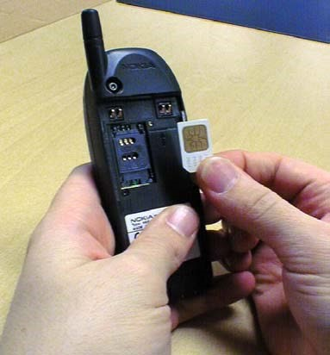

Figure 2: Inserting a SIM card in a mobile phone

### Subsystems and network elements in GSM

The GSM network is divided into three subsystems: Network Switching Subsystem (NSS), Base Station Subsystem (BSS), and Network Management Subsystem (NMS). The three subsystems are different network elements and their respective tasks are presented in the following (Stemm & Randy, 2009):

**Network Switching Subsystem (NSS)**

In Figure 1.4, the Network Switching Subsystem (NSS) contains the network elements MSC, VLR, HLR, AC and EIR (Stemm & Randy, 2009).

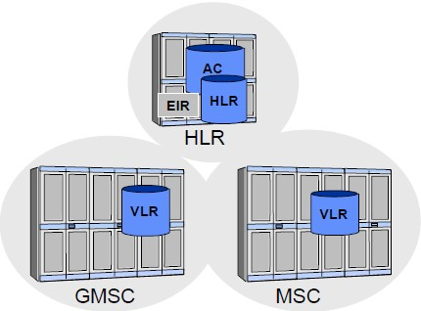

#### Figure 3: The Network Switching Subsystem (NSS)

**The main functions of NSS are:**

1. Call control
2. Charging
3. Mobility management
4. Signaling
5. Subscriber data handling

#### Network Management Subsystem (NMS)

The Network Management Subsystem (NMS) is the third subsystem of the GSM network in addition to the Network Switching Subsystem (NSS) and Base Station Subsystem (BSS), which we have already discussed. The purpose of the NMS is to monitor various functions and elements of the network. The operator workstations are connected to the database and communication servers via a Local Area Network (LAN). The database server stores the management information about the network. The communications server takes care of the data communications between the NMS and the equipment in the GSM network known as “network elements” (Mandjes & Tutschku, 2006).

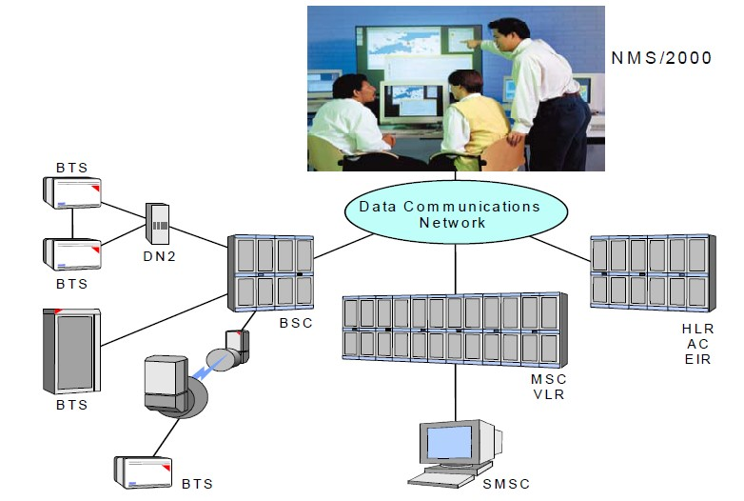

##### Figure 4: The NMS and the GSM network

The functions of the NMS can be divided into three categories:

1. Fault management
2. Configuration management
3. Performance management

These functions cover the whole of the GSM network elements from the level of individual BTSs, up to MSCs and HLRs (Stemm & Randy, 2009).

**CELLULAR NETWORK**

A cellular network provides cell phones or mobile stations (MSs), to use a more general term, with wireless access to the public switched telephone network (PSTN). The service coverage area of a cellular network is divided into many smaller areas, referred to as cells, each of which is served by a base station (BS). The BS is fixed, and it is connected to the mobile telephone switching office (MTSO), also known as the mobile switching center. An MTSO is in charge of a cluster of BSs and it is, in turn, connected to the PSTN. With the wireless link between the BS and MS, MSs such as cell phones are able to communicate with wire line phones in the PSTN (Tripathi, 2008).

Both BSs and MSs are equipped with a transceiver. Figure 2.1 illustrates a typical cellular network, in which a cell is represented by a hexagon and a BS is represented by a triangle (Stemm & Randy, 2009).

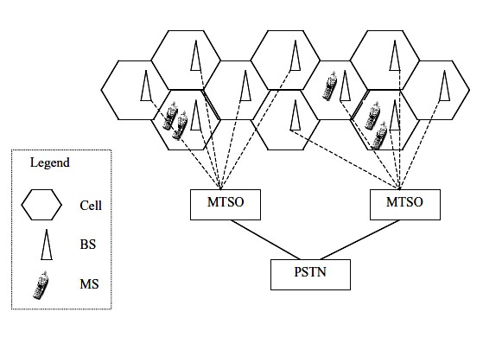

Figure 5: Typical cellular network.

Cellular systems became popular because of radio-frequency reuse, which allows more cell phone users to be supported. The cellular concept was first used in the AMPS in the United States. As a first generation of cellular systems, AMPS is a FDMA-based analog system. The 2G of cellular systems uses digital technologies. Two interim standards, IS-95 (CDMA-based) and IS-136 (TDMA based), are used in the United States, and TDMA-based GSM is used in European countries. It is clear that the 3G of cellular systems will be CDMA-based. However, the GSM community is developing WCDMA to be backward compatible with GSM while the CDMA community tries to evolve CDMA into CDMA2000. Currently researchers are studying technologies for beyond 3G (B3G) or fourth generation (4G) networks (Tripathi, 2008).

**HANDOVER SYSTEM**

The handover procedure is used when there is a need for a cell change when the MS is busy. The network is responsible for making the handover decision and performing the actual handover. To assist in the handover decision the MS will provide the network a feedback with measurements made on the downlink. Measurements will also be made on the network side (Yliopisto, 2006).

Three types of handover can be distinguished depending on the network structure:

1. Intra-BSC Handover – an MS move between two cells, belonging to the same BSC. In this case the BSC has full control over the handover.
2. Inter-BSC Handover – an MS move between two cells belonging to different BSCs under the same MSC/VLR. In this case the “old” BSC will take the decision and initiate the handover.
3. Inter-MSC Handover – an MS move between two cells belonging to different BSCs under different MSC/VLRs. In this case the “old” BSC will take the decision and initiate the handover. The “old” MSC, called anchor-MSC, and the new MSC together with the new BSC will be parts of the link procedure to commit handover (Tripathi, 2008)..

**HANOVER INITIATION**

Handover initiation is the process of deciding when to request a handover. Handover decision is based on received signal strengths (RSS) from current BS and neighboring BSs. RSSs of current BS (BS1) and one neighboring BS (BS2) is examined. The RSS gets weaker as MS goes away from BS1 and gets stronger as it gets closer to the BS2 as a result of signal propagation. The received signal is averaged over time using an averaging window to remove momentary fading due to geographical and environmental factors. Below, the four main handover initiation techniques mentioned in relative signal strength, relative signal strength with threshold, relative signal strength with hysteresis, and relative signal strength with hysteresis and threshold will be examined (Li, Shorff & Chong, 2006).

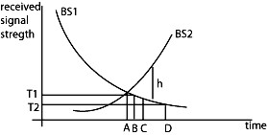

#### Figure 6: Movement of a MS in the handover zone

**ADVANTAGES OF HANOVER MANAGEMENT SYSTEM**

1. If the handover fails the call maybe temporarily disrupted or even terminated abnormally.
2. It provides very cost-effective products and solution
3. It is easy to maintain GSM networks due to availability of large number of network engineers at affordable cost this will help in revenue increase by the tele-corporation.

**DISADVANTAGES OF HANOVER MANAGEMENT SYSTEM**

1. GSM provide limited data rate capability for high data rate GSM advance vision device are used
2. In other to increase the coverage repeater are required to be installed
3. Many of the GSM technologies are patented by QUALCOMM and hence license need to be obtained from them.

**CONCLUSION**

This paper introduces in greater depth the GSM network architecture and handover process which emphasizes the architecture, the several functional network elements and their dedicated channels associated with the call. Furthermore, the paper discussed the different performance metrics used to make the handover decision. The paper presented the most important procedure of GSM handover initiation, handover types and their measurements report to ensure mobility in GSM network and to emphasis the fact that handover in GSM network are very important to maintain the quality of a call. The seminar also investigates the call handover prioritization schemes that prioritize handover calls in order to enhance the quality of service (QOS) of GSM wireless network. Extensive survey and analysis of the handover prioritization schemes that is guard channels, call admission control and handover queuing has been provided.

**RECOMMENDATION**

1. The seminar paper recommends the use of an overlapping area to reduce the call blocking and dropping probabilities.
2. It also recommends the utilization of the attractive feature of this scheme that it organizes traffic in distributed manner and doesn’t increase the system complexity.

**REFERENCES**

Ghaderi, M. (2008). Call Admission Control in Mobile Cellular Networks. *Journal of Wireless Communications and Mobile Computing, 6*(1), 6993.

Katzela, I. (2006). Channel Assignment Scheme for Cellular Mobile Telecommunication Systems- A Comprehensive Survey*. IEEE Personal Communications, 3* (3), 10-31.

Katzis, K. (2005). *Resource Allocation Techniques for High Altitude Platforms.*  University publisher, New York.

Li, J., Shorff, N. & Chong, E. (2006). *Channel Carrying: A Novel Handoff Scheme for Mobile Cellular Networks.* Retrieved March 6th, 2007 from <http://docs.lib.purdue.edu/ecetr/98/>

Mandjes, M. & Tutschku, K. (2006). *Efficient Call Handling Procedures in Cellular Mobile Networks*,Retrieved 4th June, 2007 from <http://www3.informatik.uniwuerzburgde/publications/reports.shtml>

Nielsen, T. & Wigard, J. (2000). *Performance Enhancements in a Frequency Hopping GSM Network”.* KluwerAcademic Publisher, Netherlands.

Stemm, M. & Randy, H. (2009). Vertical handoffs in wireless overlay networks. *Journal of* *Mobile Networks and Applications,* 3(2)*,* 335- 350.

Tripathi, N. (2008). *Handoff in Cellular Systems*. Retrieved March 7, 2007 from <https://www.cs.tcd.ie/~htewari/papers/tripathi98.pdf>

Yliopisto, O. (2006). *Smart Packet and Call Admission Control for Efficient Resource Management in Advanced Wireless Networks*. University press, Finland.